Huawei Enterprise S9300 Series Terabit Routing Switches
<<<<<<< Linkbar star>>>>>>>
Brochure
Documentation
Software
Materials
<<<<<<< Linkbar end>>>>>>>
tabRegion_start
<<<<<<<tab title starting>>>>>>

Product Features

Product Specifications

Product List

Applications
<<<<<<<tab title ending>>>>>>>

<<<<<<< 产品特点_start>>>>>>>
Advanced Switching Architecture to Improve Network Expansibility
Huawei's advanced switching architecture permits rapid bandwidth expansion. The highly expansible backplane enables ports to be upgraded to a rate of 40 Gbit/s or 100 Gbit/s, and is compatible with the currently used cards, helping enterprises maximize their ROI.

Reliable Design to Ensure Consistent Service
The S9300 provides redundant backup for key components, including MPUs/SRUs, power supply units, and fans, all of which are hot swappable.
A cluster requires multiple switching processes across chassis, which reduces the switching efficiency. The S9300 implements the Cluster Switching System (CSS) function, solving this problem by switching fabrics. In this way, the switching fabrics of the switches in a cluster are connected. This method saves line card slots and provides 256 Gbit/s bandwidth, which is the highest rate in the industry.

Full-Service Ethernet Switching Platform
The S9300 supports distributed Layer 2 and Layer 3 MPLS VPN functions, including MPLS, VPLS, HVPLS, and VLL, meeting the access requirements of enterprise VPNs.
The S9300 supports Layer 2 and Layer 3 multicast protocols, implements multicast replication among VLANs at the line rate, provides independent multicast QoS queues, and gives priority to services requiring minimal delay, such as voice and video services.

Excellent Security Design
The S9300 comes equipped with an integrated firewall card. It supports virtual firewalls and NAT multi-instance, allowing multiple VPN customers to share the same firewall.
The S9300 performs authentication, authorization, and accounting (AAA) on access users according to pre-defined policies. In addition, the S9300 supports 802.1x, portal, guest VLAN, and dynamic user access authentication.

Wireless and Passive Integrated Access
The S9300 EPON OLT card provides symmetric upstream and downstream bandwidths of 1.25 Gbit/s, which meets customers' increasing bandwidth requirements.
The S9300 wireless AC card supports radio frequency management. The S9300 allows APs to automatically select their radio channels and power.

Innovative Energy Saving Design
The S9300 uses a rotating ventilation channel, improving heat dissipation efficiency. In addition, it uses a variable current chip to dynamically adjust the power according to traffic, reducing power consumption by 11%. Ports can hibernate when they do not transmit traffic or consume power.
The S9300 supports IEEE 802.3az Energy Efficient Ethernet, provides the low power idle mode for the line card PHY, and switches to a lower speed (power) PHY during low link utilization.
<<<<<<<产品特点_end>>>>>>>

<<<<<<<产品规格_star>>>>>>>

<<<<<<<table starting>>>>>>>

table
Item | S9303 | S9306 |  | S9312
Backplane capacity | 3 Tbps | 6 Tbps |  | 12 Tbps
Switching capacity | 720 G/1.92 T | 2 T/5.12 T |  | 2 T/5.12 T
Throughput | 540 Mpps/1440 Mpps | 1152 Mpps/ 2880Mpps |  | 1344 Mpps/3360 Mpps
LPU slots | 3 | 6 |  | 12
VLAN | Supports access, trunk, and hybrid VLAN.
VLAN | Supports the default VLAN.
VLAN | Supports VLAN switching.
VLAN | Supports QinQ and selective QinQ.
VLAN | Supports dynamic VLAN allocation based on MAC.
MAC address | Supports dynamic learning and aging of MAC addresses.
MAC address | Supports static, dynamic, and blackhole MAC address entries.
MAC address | Filters packets based on source MAC addresses.
MAC address | Restricts MAC address learning based on ports and VLANs.
STP | Supports STP, RSTP, and MSTP.
STP | Supports BPDU protection, root protection, and loop protection.
STP | Supports BPDU tunnels.
IP routing | Supports IPv4 routing protocols, such as RIP, OSPF, BGP, and IS-IS.
IP routing | Supports IPv6 routing protocols, such as RIPng, OSPFv3, ISISv6, and BGPv4.
Multicast | Supports IGMP v1/v2/v3 and IGMP v1/v2/v3 snooping.
Multicast | Supports PIM DM, PIM SM and PIM SSM
Multicast | Supports MSDP and MBGP.
Multicast | Supports prompt leave of multicast members.
Multicast | Supports multicast traffic control.
Multicast | Supports the multicast querier.
Multicast | Supports suppression on multicast packets.
Multicast | Supports multicast CAC.
Multicast | Supports multicast ACL.
MPLS | Supports basic MPLS functions.
MPLS | Supports MPLS OAM.
MPLS | Supports MPLS TE.
MPLS | Supports MPLS VPN/VLL/VPLS.
Reliability | Supports LACP and Enhanced-Trunk.
Reliability | Supports VRRP and BFD for VRRP.
Reliability | Supports BFD for BGP, IS-IS, OSPF, and Static routing.
Reliability | Supports NSF and GR for BGP, IS-IS, OSPF and LDP.
Reliability | Supports TE FRR and IP FRR.
Reliability | Supports Ethernet OAM (802.3ah and 802.1ag).
Reliability | Supports ITU-Y.1731.
Reliability | Supports DLDP.
Reliability | Supports ISSU.
Reliability | Supports CSS.
QoS | Supports traffic classification based on the Layer-2 header, Layer-3 information, Layer-4 information, and 802.1p priority.
QoS | Supports the actions of ACL, CAR, re-mark, and schedule.
QoS | Supports the queue scheduling algorithms of PQ, WRR, DRR, PQ+WRR, and PQ+DRR.
QoS | Supports the congestion avoidance mechanisms such as WRED and tail drop.
QoS | Supports H-QoS.
QoS | Supports traffic shaping.
EPON OLT | Supports IEEE 802.3ah.
EPON OLT | Supports DBA.
EPON OLT | Limit of ONU both downstream and upstream bandwidth.
EPON OLT | Loopback test of ONU.
Configuration and maintenance | Supports Console, Telnet, and SSH terminals.
Configuration and maintenance | Supports the network management protocols, such as SNMPv1/v2/v3.
Configuration and maintenance | Supports file uploading and downloading through FTP and TFTP.
Configuration and maintenance | Supports BootROM upgrade and remote upgrade.
Configuration and maintenance | Supports hot patches.
Configuration and maintenance | Supports user operation logs.
Security and management | Supports 802.1x authentication and portal authentication.
Security and management | Supports NAC.
Security and management | Supports RADIUS and HWTACACS authentication for login users.
Security and management | Provides hierarchical protection for commands to prevent unauthorized users from accessing the equipment.
Security and management | Defends against DoS attack, TCP SYN Flood attack, UDP Flood attack, broadcast storm, and heavy traffic attack.
Security and management | Provides 1K CPU queues for CPU protection.
Security and management | Supports the ping and tracert functions based on ICMP packets.
Security and management | Supports RMON.
Service function | Supports Firewall.
Service function | Supports NAT.
Service function | Supports Netstream.
Service function | Supports IPSec.
Service function | Supports Load Balance.
Service function | Supports WLAN AC.
Energy Management | Supports IEEE 802.3az Energy Efficient Ethernet.
Chassis dimensions (width x depth x height) (mm) | 442×476×175 | 442×476×442 | 442×476×664
Chassis weight (empty) | <15Kg | <30Kg | <45Kg
Working voltage | DC: –38.4V to –72V  AC: 90V to 290V
Chassis power supply capability  (without POE power supply) | 800W | 1600W |  | 1600W
Chassis POE power supply capability | 2200W | 8800W |  | 8800W
Table

<<<<<<<table ending>>>>>>>

<<<<<<<产品规格_end>>>>>>>

<<<<<<<组网应用_star>>>>>>>

<<<<<<<table starting>>>>>>>

table
Basic Configuration
LE0BN66EDC | DC Assembly Rack(600X600X2200mm)
LE0BN66EAC | AC Assembly Rack(600X600X2200mm)
LE0KS9303 | S9303 Assembly Chassis
LE0KS9306 | S9306 Assembly Chassis
LE0KS9312 | S9312 Assembly Chassis
LE0BS9306P1 | S9306 POE Assembly Chassis
LE0BS9312P1 | S9312 POE Assembly Chassis
LE0M00FBXB00 | Wide Voltage Fan Box
LE0MACPJBX01 | APD32-2-4 Distribution Box
Monitoring Board
LE0DCMUA0000 | Centralized Monitoring Board
Main Control Unit
LE0MMCUA | S9303 Main Control Unit A
LE0DMCUA | S9303 Main Control Unit A, Clock
LE0MSRUA | S9306/S9312 Main Control Unit A
LE0DSRUA | S9306/S9312 Main Control Unit A, Clock
LE0D00SRUB00 | S9306/S9312 Main Control Unit B, Clock
Clock Board
LE0DCKMA00 | Clock Pinch Board, 1588
SRU Service Card
LE0MFSUA | Enhanced Flexible Service Unit
LE0D0VSTSA00 | Cluster Switching System Service Unit
10/100BASE-T Interface Card
LE0MF48TA | 48-Port 10/100BASE-T Interface Card(EA, RJ45)
LE0DF48TFA00 | 48-Port 10/100BASE-T Interface Card(FA, RJ45)
LE0MF48TC | 48-Port 10/100BASE-T Interface Card(EC, RJ45)
100BASE-X Interface Card
LE0MF48SA | 48-Port 100BASE-X Interface Card(EA, SFP)
LE0MF48SC | 48-Port 100BASE-X Interface Card(EC, SFP)
10/100/1000BASE-T Interface Card
LE0DT24XEA00 | 24-Port 10/100/1000BASE-T and 2-Port 10GBASE-X Interface Card (EA, RJ45/XFP)
LE0DG24TFA00 | 24-Port 10/100/1000BASE-T Interface Card  (FA, RJ45)
LE0MG48TA | 48-Port 10/100/1000BASE-T Interface  Card(EA, RJ45)
LE0DG48TFA00 | 48-Port 10/100/1000BASE-T Interface Card  (FA, RJ45)
LE0DG48TBC00 | 48-Port 10/100/1000BASE-T Interface Card  (BC, RJ45)*
LE0MG48TC | 48-Port 10/100/1000BASE-T Interface Card  (EC, RJ45)
LE0MG48TD | 48-Port 10/100/1000BASE-T Interface Card  (ED, RJ45)
100/1000BASE-X Interface Card
LE0MG24SA | 24-Port 100/1000BASE-X Interface Card  (SA, SFP)
LE0MG24SC | 24-Port 100/1000BASE-X Interface Card  (EC, SFP)
LE0MG24SD | 24-Port 100/1000BASE-X Interface Card  (ED, SFP)
LE0MG24CA | 24-Port 100/1000BASE-X and 8-Port 10/100/1000BASE-T Combo Interface Card  (SA, SFP/RJ45)
LE0DG24CEAS0 | 24-Port 100/1000BASE-X and 8-Port 10/100/1000BASE-T Combo Interface Card  (EA, SFP/RJ45, 1588)
LE0DS24XEA00 | 24-Port 100/1000BASE-X and 2-Port 10GBASE-X Interface Card(EA, SFP/XFP)
LE0D024XC00 | 24-Port 100/1000BASE-X and 2-Port 10GBASE-X Interface Card(EC, SFP/XFP)
LE0MG48SA | 48-Port 100/1000BASE-X Interface Card  (EA, SFP)
LE0DG48SFA00 | 48-Port 100/1000BASE-X Interface Card  (FA, SFP)
LE0DG48SBC00 | 48-Port 100/1000BASE-X Interface Card  (BC, SFP)*
LE0MG48SC | 48-Port 100/1000BASE-X Interface Card  (EC, SFP)
LE0MG48SD | 48-Port 100/1000BASE-X Interface Card  (ED, SFP)
100/1000BASE-X and 10/100/1000BASE-T Interface Card
LE0DG48CEAT0 | 36-Port 10/100/1000BASE-T and 12-Port 100/1000BASE-X Interface Card(EA, RJ45/SFP)
10GBASE-X Interface Card
LE0MX2UXA | 2-Port 10GBASE-X Interface Card(EA, XFP)
LE0MX2UXC | 2-Port 10GBASE-X Interface Card(EC, XFP)
LE0MX4UXA | 4-Port 10GBASE-X Interface Card(EA, XFP)
LE0MX4UXC | 4-Port 10GBASE-X Interface Card(EC, XFP)
LE0DX4UXED00 | 4-Port 10GBASE-X Interface Card(ED, XFP)
LE0DX12XSA00 | 12-Port 10GBASE-X Interface Card(SA, SFP+)
LE0DX16SFC00 | 16-Port 10GBASE-X Interface Card(FC, SFP+)
LE0DX40SFC00 | 40-Port 10GBASE-X Interface Card(FC, SFP+)
POE Interface Card
LE0DG48VEA00 | 48-Port 10/100/1000BASE-T POE Interface Card(EA, RJ45, POE)
EPON Interface Card
LE0D0E12GA00 | 12-Port 1000BASE-PX EPON Interface and 12-Port 100/1000BASE-X Interface Card (SFP)
Service Processing Unit
LE0D0VAMPA00 | Value-added Service Unit**
WAN Interface Card
LE0D0WMNPA00 | WAN Interface Service Card
WAN POS Card
CR53-P10-4xPOS/STM1-SFP | 4-port OC-3c/STM-1c POS-SFP Flexible Card
CR53-P10-4xPOS/STM4-SFP | 4-port OC-12c/STM-4c POS-SFP Flexible Card
CR53-P10-1xPOS/STM16-SFP | 1-port OC-48c/STM-16c POS SFP Flexible Pluggable Interface Daughter Card
Optical Transceiver
FE-SFP Optical Transceiver
SFP-FE-SX-MM1310 | Optical Transceiver,SFP,100M/155M,Multi-mode Module(1310nm, 2km, LC)
eSFP-FE-LX-SM1310 | Optical Transceiver, eSFP, 100M/155M, Single-mode Module(1310nm, 15km, LC)
S-SFP-FE-LH40-SM1310 | Optical Transceiver, eSFP, FE, Single-mode Module(1310nm, 40km, LC)
S-SFP-FE-LH80-SM1550 | Optical Transceiver, eSFP, FE, Single-mode Module(1550nm, 80km, LC)
622M-SFP Optical Transceiver
OST015N00 | Optical Transceiver,eSFP,622M,Single-mode Module(1310nm, 15km, LC)
OST040N00 | Optical Transceiver,eSFP,622M,Single-mode Module(1310nm, 40km, LC)
OST080N00 | Optical Transceiver,eSFP,622M,Single-mode Module(1550nm, 80km, LC)
GE-SFP Optical Transceiver
SFP-1000BaseT | Electrical Transceiver, SFP, GE, Electrical Interface Module(100m, RJ45)
eSFP-GE-SX-MM850 | Optical Transceiver, eSFP, GE, Multi-mode Module(850nm, 0.5km, LC)
SFP-GE-LX-SM1310 | Optical Transceiver, eSFP, GE, Single-mode Module(1310nm, 10km, LC)
S-SFP-GE-LH40-SM1310 | Optical Transceiver, eSFP, GE,Single-mode Module(1310nm, 40km, LC)
S-SFP-GE-LH40-SM1550 | Optical Transceiver, eSFP, GE, Single-mode Module(1550nm, 40km, LC)
S-SFP-GE-LH80-SM1550 | Optical Transceiver, eSFP, GE, Single-mode Module(1550nm, 80km, LC)
eSFP-GE-ZX100-SM1550 | Optical Transceiver, eSFP, GE, Single-mode Module(1550nm, 100km, LC)
2.5G-SFP Optical Transceiver
OSU015N00 | Optical Transceiver, eSFP, 2.5G, Single-mode Module(1310nm, 15km, LC)
OSU040N00 | Optical Transceiver, eSFP, 2.5G, Single-mode Module(1310nm, 40km, LC)
OSU080N00 | Optical Transceiver, eSFP, 2.5G, Single-mode Module(1550nm, 80km, LC)
10GE-XFP Optical Transceiver
XFP-SX-MM850 | Optical Transceiver, XFP, 10G, Multi-mode Module(850nm, 0.3km, LC)
XFP-STM64-LX-SM1310 | Optical Transceiver, XFP, 10G, Single-mode Module(1310nm, 10km, LC)
XFP-STM64-LH40-SM1550 | Optical Transceiver, XFP, 10G, Single-mode Module(1550nm, 40km, LC)
XFP-STM64-SM1550-80km | Optical Transceiver, XFP, 10G Single-mode Module(1550nm, 80km, LC)
10GE-SFP+ Optical Transceiver
OMXD30000 | Optical Transceiver, SFP+, 10G, Multi-mode Module(850nm, 0.3km, LC)
OSX010000 | Optical Transceiver, SFP+, 10G, Single-mode Module(1310nm, 10km, LC)
OSX040N01 | Optical Transceiver, SFP+, 10G, Single-mode Module(1550nm, 40km, LC)
OSXD22N00 | Optical Transceiver, SFP+, 10G, Single-mode Module(1310nm, 0.22km, LC, LRM)
BIDI-SFP Optical Transceiver
SFP-FE-LX-SM1310-BIDI | Optical Transceiver, eSFP, FE, BIDI Single-mode Module(TX1310/RX1550, 15km, LC)
SFP-FE-LX-SM1550-BIDI | Optical Transceiver, eSFP, FE, BIDI Single-mode Module(TX1550/RX1310, 15km, LC)
SFP-GE-LX-SM1310-BIDI | Optical Transceiver, eSFP, GE, BIDI Single-mode Module(TX1310/RX1490, 10km, LC)
SFP-GE-LX-SM1490-BIDI | Optical Transceiver, eSFP, GE, BIDI Single-mode Module(TX1490/RX1310, 10km, LC)
EPON Optical Transceiver
OSG020B00 | Optical Transceiver, SFP, GE, BIDI Single-mode EPON Module(TX1490/RX1310, 20km, SC)
Power
LE0MPSD16 | DC Power Module
LE0MPSA08 | 800W AC Power Module
W0PSA2200 | 2200W AC Power Module
LE0MDCPDBX00 | Front-access-maintained Cabinet Power Distribution Box
LE0MACPJBX00 | INtess ICD,IN6W18L10A,Intelligent Value Added Special Service Power Junction Box, 8-Channel Output,Each With Rated Current Of 10A
Cable & Converter
LE0CQP10QP00 | QSFP High Speed Cable, 10m
Software
LE0SMS129300 | Quidway S9300 Basic SW, V100R002
LE0SMS139300 | Quidway S9300 Basic SW, V100R003
LS0SMS169300 | Quidway S9300 Basic SW, V100R006
LE0STO129300 | Quidway S9300 SW Upgrade, V100R001 to V100R002
LE0STO139300 | Quidway S9300 SW Upgrade, V100R002 to V100R003
LS0STO169300 | Quidway S9300 SW Upgrade, V100R003 to V100R006
LE0SMPLS9300 | MPLS Function License
LE0SNQAF9300 | NQA Function License
LE0SIPV69300 | IPV6 Function License
LE0SWLAN9300 | WLAN Access Controller AP Resource License-128AP
Document
LE0I000DOC00 | Quidway S9300 Terabit Routing Switch Product Documentation
Installation Material
E000FMT00 | Subassembly for Fiber Winding Box
Table
<<<<<<<table ending>>>>>>>

*: has 200 ms caching capability.
**: supports firewall, IPSec, wireless AC, load balancing, and NetStream.
<<<<<<<组网应用_end>>>>>>>

<<<<<<<选配信息_star>>>>>>>
1 Application in Large-Scale Campus Networks
The S9300 can be used to build highly reliable, expansible, and manageable high performance enterprise campus networks. The S9300 supports distributed IPv4/IPv6/MPLS wire-speed switching and provides high-density 10G data throughput for core and convergence nodes on enterprise campus networks. The S9300 supports the wireless AC module and can integrate it with the campus core device, saving the network investment. The S9300 also supports hardware CPU queues to protect the enterprise core against DDoS attacks and security threats.
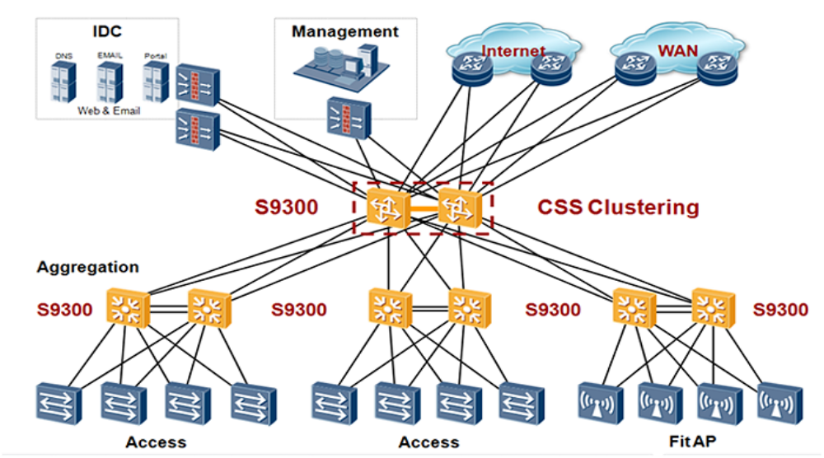
2 Applications in Large-Scale Data Centers
The S9300 functions as a high-density 10G core and convergence node in large-scale data centers, helping enterprises build highly reliable, non-blocking, and virtualized data center networks. The S9300 deploys various technologies to ensure uninterrupted services, including ISSU upgrades, IP FRR, hardware-level BFD, NSF, VRRP, and E-Trunk. Using the CSS and integrated load balancing solutions, the S9300 improves the network efficiency and reduces network maintenance costs.
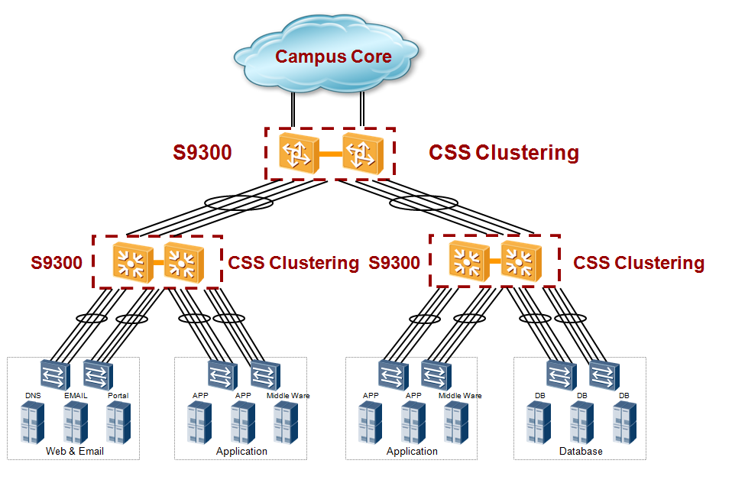

<<<<<<<选配信息_end>>>>>>>

<<<<<<<tabRegion_end>>>>>>>

